SIMATS ENGINEERING
ASSESSMENT TOOL 2

AYUSH MOHAPATRA 192411263
COURSE NAME: INTERNET PROGRAMMING
COURSE CODE: CSA43
COURSE OUTCOME COVERED
CO-1: Develop well-structured, standards-compliant web pages using HTML/XHTML and XML, and apply Internet protocols and HTTP communication mechanisms for web content delivery. (L2)
Assessment Tool: Data Interpretation (Medium)
Weightage: 20%
QUESTIONS: Total Marks: 20
1: HTTP Response Analysis
A web server returns the following HTTP response header:
HTTP/1.1 200 OK
Date: Mon, 01 Apr 2026 10:00:00 GMT
Content-Type: text/html
Content-Length: -150
Connection: keep-alive
Questions:
1. Identify any incorrect or invalid fields in the header.
2. Analyze the issue with Content-Length and explain its impact.
3. Determine whether the status code matches the response correctness. 4. Suggest corrections for the identified errors.
2: DOM Structure Analysis
Consider the following DOM tree representation:
<html>
<head>
<title>TestPage</title>
</head>
<body>
<div>
<p>HelloWorld
</div>
</body>
</html>
Questions:
1. Identify missing or improperly closed elements.
2. Analyze how the browser will interpret this structure.
3. Determine the impact on rendering and layout.
4. Suggest corrections to make the DOM valid.
3: GET vs POST in Login System
A login system uses two different methods:
Method URL Example Data Visibility Security Level GET /login?user=admin&pass=1234 Visible in URL Low POST /login Hidden in body Moderate
Questions:
1. Interpret the differences in data transmission between GET and POST. 2. Analyze which method is more suitable for login and why. 3. Identify security risks in using GET for authentication.
4. Suggest best practices for secure login implementation.
4: HTML Code Inspection
Analyze the following HTML snippet:
<!DOCTYPE html>
<html>
<head>
<title>Sample</title>
</head>
<body>
<h1>Welcome
<p>This is a paragraph
<img src="image.jpg">
</body>
</html>
Questions:
1. Identify missing closing tags.
2. Analyze issues with the <img> tag.
3. Determine how browsers will handle these errors.
4. Suggest a corrected version of the code.
5: Browser-Server Communication Flow
The following sequence describes a web request:
1. User enters a URL in the browser
2. DNS lookup occurs
3. HTTP request is sent
4. Server processes request
5. Response is returned
6. Browser renders page
Questions:
1. Interpret each step in the communication flow.
2. Identify where delays can occur.
3. Analyze the role of DNS in the process.
4. Suggest optimizations to improve performance.
Code of Conduct:
I AYUSH MOHAPATRA 192411263 (Name / Reg No) certify that this submission is my original work and that I have adhered to the guidelines specified for this assessment. I understand that any violation of academic integrity rules will result in disciplinary action.
Signature of the student:
AYUSH MOHAPATRA

1. HTTP Response Analysis
Given response:
HTTP/1.1 200 OK
Date: Mon, 01 Apr 2026 10:00:00 GMT
Content-Type: text/html
Content-Length: -150
Connection: keep-alive

1.1 Incorrect or invalid fields
The Content-Length field is invalid because its value is -150. Content-Length must be a non-negative decimal integer representing the number of message-body bytes. The Date field also contains a weekday/date mismatch: 1 April 2026 is a Wednesday, not a Monday. The other fields are syntactically plausible, assuming the server supports persistent connections.

1.2 Issue with Content-Length and its impact
A negative content length cannot describe the size of an HTTP response body. It may cause the response to be rejected or handled inconsistently by clients and intermediaries. Incorrect message framing can also contribute to parsing errors and, in some circumstances, security problems when different systems interpret the message differently.

1.3 Does the status code match?
HTTP/1.1 200 OK means that the request succeeded. It does not guarantee that every header is valid. Therefore, the success status does not make the invalid Content-Length or incorrect Date value correct.

1.4 Corrections
Use the actual body length in bytes, for example Content-Length: 150 only if the body is exactly 150 bytes. If the body length is unknown, use valid HTTP message framing rather than inventing a value. Correct the Date header to “Wed, 01 Apr 2026 10:00:00 GMT” if that timestamp is intended. Keep “200 OK” only if the request was successfully processed.

2. DOM Structure Analysis

2.1 Missing or improperly closed elements
The paragraph element <p> is opened but not explicitly closed before the </div> tag. The div, body, and html elements are closed. In HTML, a paragraph end tag can sometimes be implied when another block-level element begins or when its parent closes, but explicitly closing it makes the structure clearer and more reliable.

2.2 Browser interpretation
HTML browsers use error-recovery rules to construct a DOM even when markup is imperfect. When the browser reaches </div>, it will generally close the open paragraph as part of parsing and produce a paragraph inside the div. Exact error recovery can depend on the markup and parsing context.

2.3 Impact on rendering and layout
The page will probably still display “HelloWorld” inside a paragraph. However, omitted end tags can make the structure harder to maintain and can cause unexpected nesting or spacing when more elements are added. This may affect CSS selectors, layout, accessibility, and scripts that depend on the DOM.

2.4 Corrected DOM
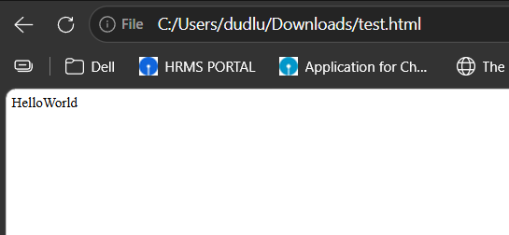
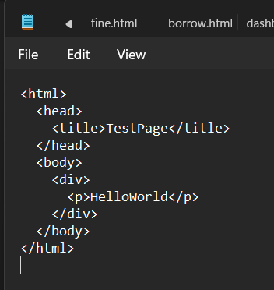

3. GET vs POST in Login System

3.1 Differences in data transmission
GET commonly sends parameters in the URL query string, such as /login?user=admin&pass=1234. These values can appear in browser history, server logs, copied links, and referrer information. POST sends submitted fields in the request body, so they are not ordinarily displayed in the URL. However, POST data is not automatically encrypted; HTTPS is needed to protect credentials in transit.

3.2 Suitable method for login
POST is more suitable for submitting login credentials because it avoids placing passwords in the URL. It is not secure by itself, so the login page and submission must use HTTPS and the server must validate credentials safely.

3.3 Risks of GET for authentication
Using GET may expose credentials through browser history, URL sharing, proxy or server logs, analytics, screenshots, and referrer leakage. URLs may also be cached or recorded by monitoring systems. These exposures can allow unauthorized people to obtain the username and password.

3.4 Best practices
- Submit credentials using POST over HTTPS throughout the login flow.
- Never put passwords, session tokens, or other secrets in URLs.
- Store passwords using a strong, salted password-hashing algorithm such as Argon2id or bcrypt; never store plaintext passwords.
- Use secure session handling: cookies should be Secure, HttpOnly, and appropriately configured with SameSite.
- Apply rate limiting, generic authentication error messages, and multi-factor authentication where appropriate.
- Protect authenticated actions against CSRF where relevant, validate inputs, and avoid logging passwords or secrets.

4. HTML Code Inspection

4.1 Missing closing tags
The <h1> and <p> elements are not explicitly closed. In HTML, their end tags may be inferred by the parser in some contexts, but explicitly closing them is recommended for clear, maintainable markup. The img element is a void element and does not need a closing tag.

4.2 Issues with the img tag
The image has a src attribute but no alt attribute. The alt attribute provides a text alternative for screen-reader users and when the image cannot load. The path image.jpg must also point to an existing, accessible image file. Use alt="" only when the image is purely decorative.

4.3 Browser handling
Browsers generally recover from these HTML omissions and attempt to render the heading, paragraph, and image. The missing end tags do not necessarily prevent the page from loading, but the browser may infer element boundaries. If the image path is wrong, a broken-image indicator may appear; without suitable alternative text, accessibility is reduced.

4.4 Corrected HTML
<!DOCTYPE html>
<html lang="en">
<head>
<meta charset="UTF-8">
<meta name="viewport" content="width=device-width, initial-scale=1.0">
<title>Sample biuwehbcuiweb </title>
</head>
<body>
<h1>Welcome</h1>
<p>This is a paragraph.</p>
<img src="image.jpg" alt="Description of bnscvoiwbvw the image">
</body>
</html>
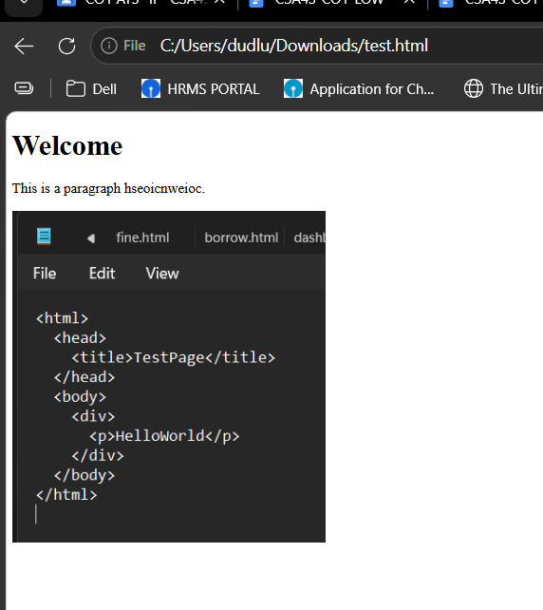

5. Browser-Server Communication Flow

5.1 Interpretation of each step
1. User enters a URL — The browser parses the URL to identify the scheme, host, port, and requested resource.
2. DNS lookup occurs — The browser or operating system checks available caches and, if necessary, asks a DNS resolver to translate the domain name into an IP address.
3. HTTP request is sent — The browser establishes the required network connection (including TLS for HTTPS) and sends an HTTP request containing the method, path, headers, and any applicable body.
4. Server processes request — The server receives the request, applies routing and application logic, accesses resources or databases if needed, and prepares a response.
5. Response is returned — The server sends an HTTP status code, headers, and usually a response body such as HTML, JSON, or an image.
6. Browser renders page — The browser parses HTML into the DOM, processes CSS, runs applicable JavaScript, fetches referenced resources, and paints the page.

5.2 Where delays can occur
Delays may occur during DNS resolution, connection establishment, TLS negotiation, network transmission, server-side processing, database queries, transfer of large response bodies, and browser parsing, JavaScript execution, or image/font loading. Congestion, packet loss, overloaded servers, and third-party resources can add further delays.

5.3 Role of DNS
DNS maps a human-readable domain name, such as example.com, to the IP address needed to reach the server. It helps the browser locate the destination. DNS does not itself deliver the webpage. Cached DNS results can reduce repeated lookup time, while slow or failed DNS resolution can delay or prevent the connection.

5.4 Performance optimizations
- Use efficient DNS hosting and sensible DNS caching/TTL settings.
- Use a CDN and geographically distributed servers for static resources.
- Enable HTTP/2 or HTTP/3, keep connections reusable, and configure TLS efficiently.
- Compress text responses with Brotli or gzip and optimize images, fonts, and other assets.
- Cache static content and suitable API responses using correct cache headers.
- Optimize application code and database queries; reduce unnecessary redirects and requests.
- Defer non-critical JavaScript, minimize render-blocking CSS, and lazy-load below-the-fold images.
- Monitor real-user performance and server response times to identify bottlenecks.

RUBRICS FOR CALCULATION:
Criteria | Weightage | Level 4 (Exemplary) | Level 3 (Proficient) | Level 2 (Developing) | Level 1 (Beginning) | Marks Awarded
Understanding of Data | 25% | Accurately interprets all data patterns, trends, and relationships | Interprets data correctly with minor gaps | Partial understanding; misses key trends | Misinterprets or fails to understand data | 23 / 25
Analysis | 25% | Provides deep analysis with strong logical reasoning and justification | Provides reasonable analysis with some justification | Basic analysis with weak reasoning | No meaningful analysis provided | 22 / 25
Application of Concepts | 20% | Effectively applies relevant concepts/tools to interpret data accurately | Applies concepts with minor errors | Limited application; requires guidance | Unable to apply concepts to data | 18 / 20
Conclusion | 20% | Draws clear, meaningful conclusions with strong insights and implications | Provides valid conclusions with moderate insights | Conclusions are vague or weak | No clear or valid conclusions | 18 / 20
Clarity | 10% | Presents interpretation clearly using proper structure, visuals, and terminology | Generally clear with minor issues | Lacks clarity or proper structure | Poor presentation and difficult to understand | 9 / 10
Total Marks | 100% |  |  |  |  | 90 / 100

